**Jenkins Master and Slave configuration**

**Prerequisites**

1. Jenkins server
2. Slave server with Java installation

**Procedure:**

Navigate to the Jenkins dashboard.

* Click on "**Manage Jenkins**" in the left navigation menu.

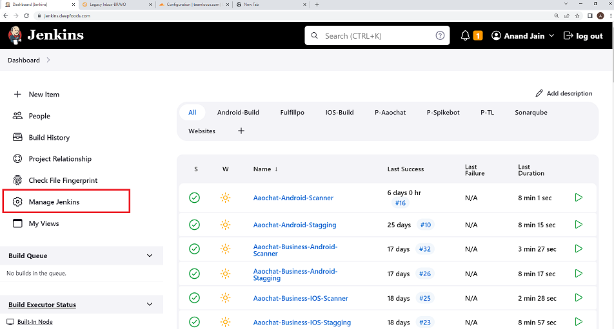

* Click on "**Manage Nodes and Clouds**".

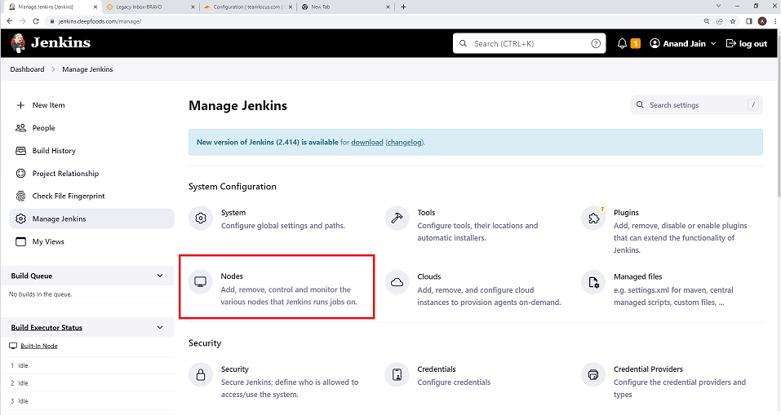

* Click on "**New Node**".

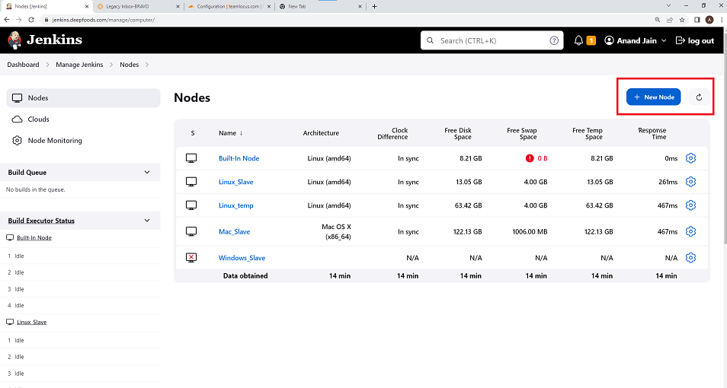

* Give your new agent a name, select "**Permanent Agent**" and click "**OK**".

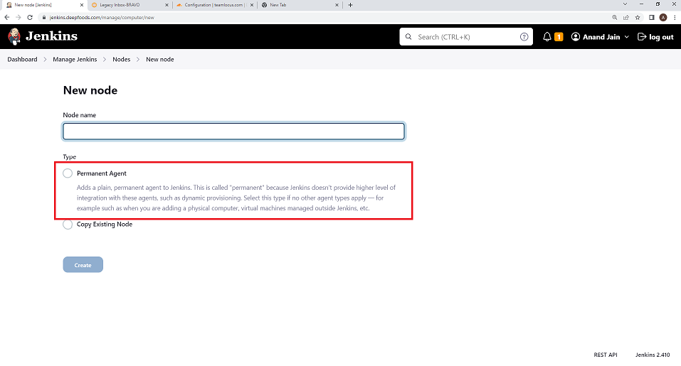

You will now be asked to configure the agent. Here are the details you need to fill in:

**Description**: A description of the agent.

**# of executors**: Number of jobs that the agent can execute simultaneously.

**Remote root directory**: An absolute path of a directory on the agent where Jenkins places its files.

**Labels**: Space-separated tags used to assign jobs to agents.

Next, in the `Launch method` field, choose "Launch agent via SSH".

**Launch method:**

* + Launch agent by connecting it to the controller.
  + Launch agent via execution of command on the controller.
  + Launch agent via SSH.

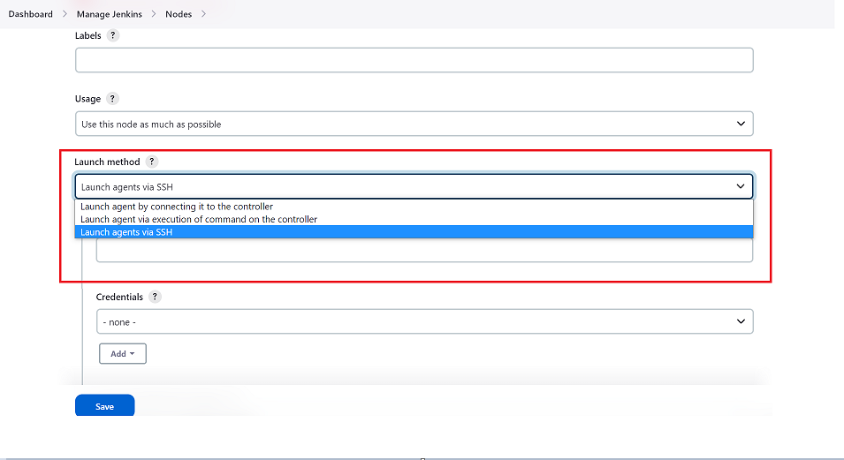

* Step to connect slave as **Launch agent via SSH**.

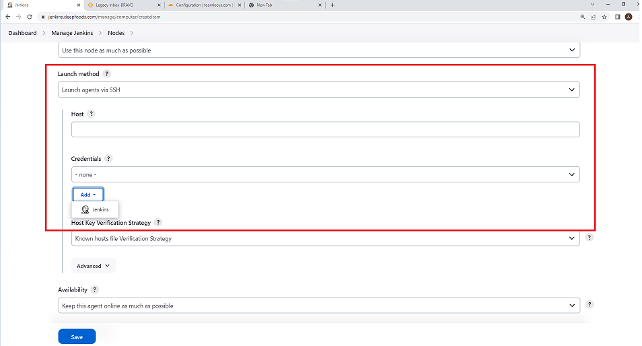

You will need to add further details for the SSH configuration:

- **Host**: IP address/hostname of the agent.

- **Credentials**: Add the agent's SSH credentials here.

Click on "**Add**", then "**Jenkins**". Input username, and then you can choose either password or private key for SSH authentication.

- Host Key Verification Strategy: Strategy used to verify the agent's SSH key. For a secure connection, use "**Known hosts file Verification Strategy**" or "**Manually provided key Verification Strategy**".

* **Availability:**
  + Keep this agent online as much as possible
  + Bring this agent online according to a schedule
  + Bring this agent online when in demand, and take offline when idle

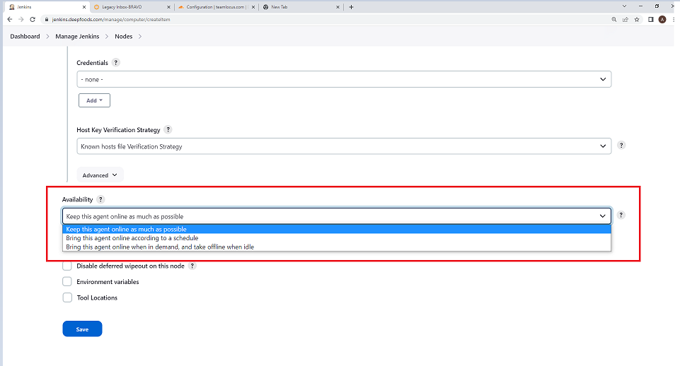

* Click on "**Save**".

Jenkins will now try to connect to the slave agent using the provided SSH details. If the connection is successful, the agent will become part of your Jenkins architecture and appear as online in your Jenkins dashboard.

Remember to ensure that the Jenkins master can reach your agent node via SSH. You also need to have Java installed on the agent machine because Jenkins uses Java for the agent runtime.

